‘Out of the Mouths of Babes’ – What can psychodynamic therapists learn from working with young children? A grounded theory study.
Ethics Approval Reference: EQ C1A_18_016
Are you a psychodynamic practitioner who works with children aged 3-11?

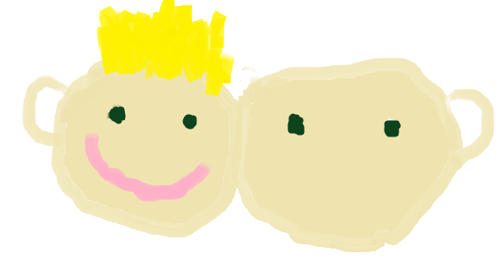

Could you help contribute to research in the field of child psychotherapy? This study aims to determine what psychodynamic practitioners can learn by working with primary school aged children. It is based on the idea that children have their own knowledge and insights into their inner workings and the workings of the world around them.

We are looking for psychodynamic practitioners who are working, or have worked, with children in the 3-11 age range. You would be invited to participate in one 50-minute interview at a location convenient to you.

If you are interested and would like more information, or have any questions, please contact Emma Jaffe by email at emma.jaffe@kellogg.ox.ac.uk. There is no obligation to take part.
Thank you!

