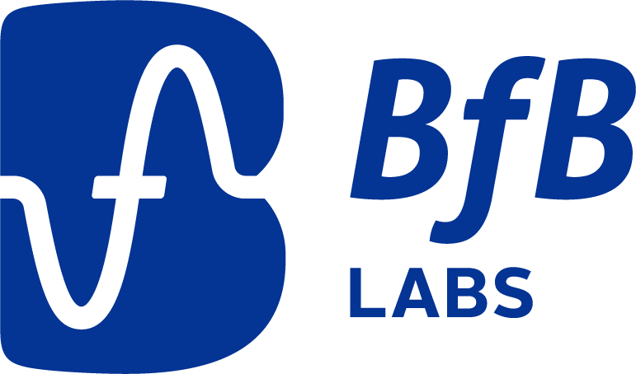

**I-DIGIT (Investigating Digital Therapy)**

|  |
| --- |
| **CONTENTS:**   1. **Why is the research being done?** 2. **Why have I been invited to take part?** 3. **do I have to take part?** 4. **what will I be asked to do if i decide to take part?** 5. **where will the research happen?** 6. **are there any risks?** 7. **WHAT ARE THE POTENTIAL BENEFITS?** 8. **who will know that i AM TAKING part?** 9. **Who is running the project?** 10. **who has checked the research?** 11. **what will you do with what you find out?** 12. **what if i am UNhappy about the RESEARCH?** 13. **data protection - how we use your information** |

**Participant Information Sheet (PROFESSIONALS)**

**Full Study Title: Graded Exposure Therapy Through a Standalone Digital Therapeutic Game for Children Aged 7-12 Years with Anxiety Disorders**

You have been given this information sheet because we would like to invite you to take part in a research project. This information sheet is designed to help you decide whether or not to participate in the research. Please read this carefully. You do not have to decide whether or not you agree to participating straight away. If there is anything that’s not clear or you want to know more, you can find the team’s contact details at the end of this information sheet.

1. **Why is the research being done?**

Currently, only a small minority of young people experiencing anxiety disorders access evidence-based treatment. Further, children from disadvantaged or marginalised communities are more likely to experience anxiety disorders but are the less likely to access mental health services than their peers.

Offering therapeutic interventions to children and young people via digital technologies has the potential to offer an efficient and cost-effective means of increasing access to evidence-based interventions. However, for the potential benefits of digital treatment delivery to be realised, it is important that we understand how those who provide, manage and commission mental healthcare services view these digital technologies.

This study aims to explore how healthcare professionals, service managers and commissioners view the use of digital technologies in the provision of mental health treatment for children and young people. Further, we aim to learn about the barriers and facilitators of implementation of new digital technologies within children and young people’s mental health services, and to understand how any barriers can be overcome.

As part of the study, we are focusing on an example of a digital intervention for childhood anxiety currently commissioned by NHS services called ‘Lumi Nova: Tales of Courage’. Lumi Nova is a game-based digital therapy designed to reduce anxiety in children aged 7–12- years old by delivering graded exposure. We will ask whether you have experience with Lumi Nova as part of the focus group and, if applicable, for your views on it. However, it is not necessary to have experience of Lumi Nova to take part.

1. **Why HAVE I been INVITED to take part?**

We are inviting you to take part because you work in a role which involves providing, managing or commissioning mental healthcare services for children and young people.

1. **DO I HAVE TO TAKE PART?**

No. It is up to you whether or not to take part. If you give your consent to take part but you change your mind, you can withdraw from the research without giving a reason. A decision not to take part or withdraw will not impact your professional role or any care or support you receive. If you withdraw from the study, we will use the information we have collected so far unless you tell us you would prefer us not to. You can tell us you no longer want us to use your information up until the point the data analysis is finalised.

1. **WHAT WILL I BE ASKED TO DO IF I DECIDE TO TAKE PART?**

If you are interested in participating, we will invite you to speak with a member of the research team who will explain the study and answer any questions you may have. If, following this discussion, you decide you would like to take part, the researcher will complete a consent form with you to document your consent to participate.

You will then be invited to join a group discussion (focus group) with a small number of other professionals with relevant professional experience. The discussion will take place online using video conferencing software. The discussion will be co-facilitated by a member of the research team and a member of our Children and Families Advisory Panel and will focus on group members views on the use of digital technologies within NHS-funded mental health services for children and young people.

We will video record the focus group so that we have an accurate record of the discussion. We will use this recording to transcribe the focus group and will delete the file once transcription has been completed. Participants will be asked whether they are happy for recording to begin on before the discussion begins and can leave the call, turn off their camera or mute their audio at any time should they wish to stop or take a break. We may quote some of your words in reports of the research but will not include any information that could identify you (such as your name, date of birth, service or address).

1. **WHERE WILL THE RESEARCH HAPPEN?**

The initial meeting/conversation with the researcher can take place via video call, over the telephone, or in-person (assuming the current public health situation means it would be safe to do so). The focus group will take place online using video conferencing software.

1. **ARE THERE ANY RISKS?**

There is a possibility that the discussion will cover topics that you find uncomfortable or distressing. However, there is no obligation to discuss anything you do not feel comfortable talking about and you will be free to stop or take a break at any time. If you become upset while taking part in the research, a member of the research team will stay with you for a period of time after the focus group to and will offer to signpost you to sources of further support should you need it.

1. **WHAT ARE THE POTENTIAL BENEFITS?**

Taking part is unlikely to benefit you directly. However, we hope the information you provide will be used to improve the support available to children, young people and families in the future. We will reimburse all reasonable expenses, if incurred.

1. **Who will know that I am taking part?**

All the information we collect about you will be kept on secure computer systems that only the research team can access to ensure privacy and confidentiality. The information collected about you as part of the research will be kept strictly confidential except in the case that we need to pass information to appropriate bodies in order to keep you or someone else safe from serious harm. Individuals responsible for auditing the research will be given access to your information where this is necessary for them to ensure that the study is being run properly.

1. **WHO IS RUNNING THE PROJECT?**

The research is being run by a team of researchers from Norfolk and Suffolk NHS Foundation Trust, Eastern Academic Health Science Network and BfB Labs.

1. **WHO HAS CHECKED THE RESEARCH?**

Research projects like this one can’t go ahead without being checked and approved by an NHS Research Ethics Committee. This committee checks that risks of the research have been kept to a minimum and that we give you all the information you need to make an informed choice about whether or not to take part. This study has been checked by North West - Preston Research Ethics Committee (Reference: 22/NW/0195).

1. **WHAT WILL HAPPEN TO THE RESULTS OF THE RESEARCH?**

The results of the research will be shared with children, parents/carers, healthcare providers and commissioners, digital health technology industry leaders, and other researchers. Care will be taken to ensure that no-one can tell who took part in the research from reading or hearing about the results (we won’t include real names or other details that could identify you).

We will ask you whether you would like us to keep you updated about the project and whether you’d like to receive a summary of the results once it’s finished.

1. **What if I am not happy about the project?**

If you are unhappy about any part of the research or if you feel you have been harmed, you can ask to speak to a member of the research team who will do their best to help and who can arrange for further support as needed.

If you would like to speak to someone outside of the research team for more information or if something goes wrong, you can share your concerns or make a formal complaint through NSFT’s Customer Services team: email [customer.service@nsft.nhs.uk](mailto:customer.service@nsft.nhs.uk)​​ or call 01603 421486. Please note that the study is covered by standard NHS indemnity and compensation arrangements only.

1. **data protection – how we use your information**

Norfolk and Suffolk NHS Foundation Trust is the sponsor for this study based in the United Kingdom. We will be using information from you in order to undertake this study and will act as the data controller for this study. This means that we are responsible for looking after your information and using it properly. Norfolk and Suffolk NHS Foundation Trust will keep identifiable information about you for 10 years after the study has finished. Information will be stored securely on NHS premises. Keeping research data after the study has ended helps us to comply with legislation and allows the data to be used for future research if this is approved.

Your rights to access, change or move your information are limited as we need to manage your information in specific ways in order for the research to be reliable and accurate. If you withdraw from the study, we will keep the information about you that we have already obtained. To safeguard your rights, we will use the minimum personally-identifiable information possible.

Norfolk and Suffolk NHS Foundation Trust will use your name and contact details to contact you about the research study, and make sure that relevant information about the study is recorded, and to oversee the quality of the study. Individuals from Norfolk and Suffolk NHS Foundation Trust and regulatory organisations may look at your research records to check the accuracy of the research study.

The only people in Norfolk and Suffolk NHS Foundation Trust who will have access to information that identifies you will be people who need to contact you to arrange meetings or audit the data collection process. The people who analyse the information will not be able to identify you and will not be able to find out your name or contact details.

If you want to complain about how researchers have handled your information, you should contact the study’s Chief Investigator. If you remain unhappy, you can contact the Trust’s Data Protection Officer, Richard Green, by emailing: [dataprotectionofficer@nsft.nhs.uk](mailto:dataprotectionofficer@nsft.nhs.uk).

You can find out more about how we use your information in research by reading the document ‘Managing Your Information: A guide for research participants’, available here: <https://www.nsft.nhs.uk/research-compliance-and-policies>

|  |
| --- |
| **THANK YOU FOR READING THIS!**  Thank you for taking the time to read this information sheet. If you decide to take part in the project you will be given a copy of this information sheet and your consent form in case you want to refer back to them in future.  If you would like more information about this project, you can get in touch with Jon or Tim by phone or email using the details below. Or ask the person who told you about this project to pass on a message to the team and one of us will get back to you as soon as possible.    Dr Jon Wilson  Chief Investigator  [jon.wilson@nsft.nhs.uk](mailto:jon.wilson@nsft.nhs.uk)  Tel: 07917 880357  Dr Tim Clarke  Work Package Lead  timothy.clarke@nsft.nhs.uk  Tel: 07824527372 |